1. Problem Definition of Project

Campus Coin is a student-first personal finance and budget tracking web application designed specifically for college and university students. The application provides specialized financial tracking features tailored to student life, allowing users to log irregular income sources—such as family allowances, part-time job earnings, scholarships, and gifts—and manage student-specific expense categories like campus food, hostel or rent, academics, subscriptions, transport, and entertainment. The platform operates as a responsive full-stack web application based on a three-tier architecture comprising a Presentation Layer, an Application/API Layer, and a Relational Data Layer. At present, many students attempt to manage their finances manually or rely on generic personal-finance tools built for salaried adults with fixed income cycles and linked bank accounts. Because generic tools are often subscription-gated, overly complex, or require bank integrations, students frequently struggle to track where their money actually goes and fail to maintain consistent budgeting habits.

The current manual tracking or reliance on generic applications causes several problems for college students. Student financial data is often unmonitored or lost when recorded informally across separate notes or spread out across irregular pay periods. Managing budgets manually without centralized progress alerts makes it easy for students to accidentally exceed category spending caps. In addition, students spend significant time trying to categorize expenses or calculate monthly totals without clear visual trend reports. Most generic tools also fail to offer student-oriented saving tips, plain-language financial guidance, or mechanisms to analyze unusual spending spikes. Furthermore, without automated administration and role-based control, system managers cannot effectively oversee default categories or view system-wide usage statistics.

To solve these problems, this project proposes to develop a system called the "Campus Coin Web Application". The main goal of this system is to provide a lightweight, interactive, and student-centric platform that empowers students to take control of their financial habits without requiring linked bank accounts or complex financial knowledge. The system will provide several core functions, including user authentication and profile management, admin oversight, and category management for both income and expenses. To organize finances efficiently, it will support quick income and expense logging, CSV file import, category budget goal setting with real-time alert notifications, and historical transaction management. For financial analysis, the system will handle monthly report generation, 6-month income versus expense trend charts, daily and weekly summaries, and PDF/image report exports. To ensure personalization and modern intelligence, it will include a personalized saving tips engine, optional AI-driven expense categorization, and AI-generated monthly spending narrative insights. Ultimately, this system is expected to make student budget tracking effortless, eliminate manual tracking friction, and foster long-term campus financial literacy.

2. Customer Requirements Specification (CRS)
2.1 Client: The target customers are university and college students, hostel communities, and campus financial-literacy initiatives.
2.2 Business/Project Objective:
- Project Overview: The Campus Coin project aims to build a smart, lightweight, and user-friendly personal finance and expense tracking Web application specifically designed for students.
- Current Concerns: Students often have irregular income sources (such as allowances, part-time jobs, and scholarships) but rarely track their spending. Generic finance apps are typically built for salaried adults, making them too complex and unsuitable for student habits.
- Expectations from the System: Build a dynamic web application utilizing a 3-tier architecture (Presentation, Application/API, Data Layer) that allows students to log income and expenses, set budgets, and view reports without requiring real bank account integration. The system should feature an optional AI assistant to automatically categorize transactions and generate personalized saving tips.
2.3 Inputs provided by the Client:
2.3.1 User Authentication and Management:
- Inputs to the System: Account registration details (name, academic year, savings goal, email, password) and login credentials.
- Outputs from the System: Authentication status (Success/Failure), user profile dashboard, and role-based navigation interfaces (Admin or Student).
- Process Involved in the System: The system receives the input, encrypts the password, manages secure sessions, and directs the user to either their personal transaction dashboard or the administrative control panel based on their role.
2.3.2 Category Management:
- Inputs to the System: Custom category names and category types (Income or Expense).
- Outputs from the System: Categorized lists displayed on the application (e.g., Food, Transport, Academics, Allowance).
- Process Involved in the System: Users or Admins input category data. The system allows adding, editing, and deleting personal categories, saving them directly to the database for future transaction assignments.
2.3.3 Transaction Logging & History (Manual or CSV Import):
- Inputs to the System: Transaction details (amount, description, category, recurring cycle) or bulk data imported from CSV files.
- Outputs from the System: A detailed historical log of recorded income and expenses, along with the current month's balance.
- Process Involved in the System: Users enter data via quick-add forms or CSV uploads. The system records the complete history, allowing users to edit or delete transactions while maintaining overall data integrity.
2.3.4 Budget Setup, Real-time Notifications, and Alerts:
- Inputs to the System: Monthly budget limits for specific expense categories (e.g., 30 USD for Food).
- Outputs from the System: Progress bars illustrating budget consumption and in-app notifications/alerts.
- Process Involved in the System: The system tracks spending in real-time and compares it against the predefined budgets. When a category nears or exceeds its limit, the system triggers a warning notification.
2.3.5 Monthly Reports, Spending Trends, Charts, and Exports:
- Inputs to the System: Filter criteria such as date ranges, specific categories, or income sources.
- Outputs from the System: Category-wise monthly spending reports, 6-month trend charts, daily/weekly summaries, and exported report files (PDF or image formats).
- Process Involved in the System: The system aggregates data from the database, generates visual charts, and provides functionality for users to export or share these reports via email.
2.3.6 AI-Driven Expense Categorization & Smart Insights:
- Inputs to the System: Free-text transaction descriptions entered by the user and their historical spending patterns.
- Outputs from the System: Automatic category suggestions (e.g., suggesting "Food" when "Campus Cafe" is typed) and plain-language narrative summaries with actionable saving tips.
- Process Involved in the System: AI/ML techniques analyze the text input and user habits to suggest categories. The AI also reviews monthly spending trends, flags unusual spikes, and generates easily achievable financial advice.
2.4 Expected Delivery Dates:
- Expected delivery by the end of the semester schedule (e.g., May 2026).
2.5 List of Deliverables:
- Project Documentation (Including Problem Definition, Database Design, DFDs, Flowcharts, etc.).
- Website (Complete Source Code for the Campus Coin system).
- A demonstration video (.mp4 file) showing the working Web application and all functional requirements.
- Installation Instructions (MANDATORY) and user credentials/passwords for all user types.
2.6 Hardware Requirements:
- Server/Client: Intel Core i5/i7 Processor or higher, minimum 16 GB RAM, and at least 500 GB Hard Disk space.
2.7 Software Requirements:
- Frontend: HTML5, CSS3, Bootstrap, ReactJS/AngularJS/Angular, JavaScript, and jQuery.
- Backend: Java SDK (NetBeans/Eclipse, Jakarta EE), C# (ASP.NET MVC), PHP (Laravel Framework), Python (Flask or Django), or Node.js (Express.js).
- Database: MySQL, SQL Server, MongoDB, or JSON.
- Integrations: AI/ML services for categorization (e.g., OCR) and AI Chatbot assistants like tawk.to or Tidio. The application must be responsive and compatible with modern web browsers.
2.8 Scope of the Work (Detailed Pages by User Role):
- 2.8.1 Student Pages (Frontend Portal):
  - Personalized Dashboard: Displays a custom greeting, current month balance, budget progress, and quick-add buttons.
  - Transaction Logging: Quick-add forms for logging income and expenses, including support for recurring entries.
  - Reports & Insights: Category-wise reports with PDF export capabilities, and an insights feed displaying AI-generated narratives and saving tips.
  - Category Management: Interfaces to add, edit, or delete personal custom categories.
  - Bookmarking: Allows users to bookmark or "pin" useful saving tips and monthly insights for later review.
- 2.8.2 Admin Pages (Backend Dashboard):
  - System Category Management: Add, edit, or remove default expense and income categories available to all platform users.
  - User Management: View, disable, or reset user accounts.
  - Announcement Control: Create and manage system-wide announcements or tip templates.
  - Usage Statistics: View overall system metrics, including the number of active users, total transactions logged, and the most frequently used categories.

3. Database relationships at the presentation level
3.1 Architecture
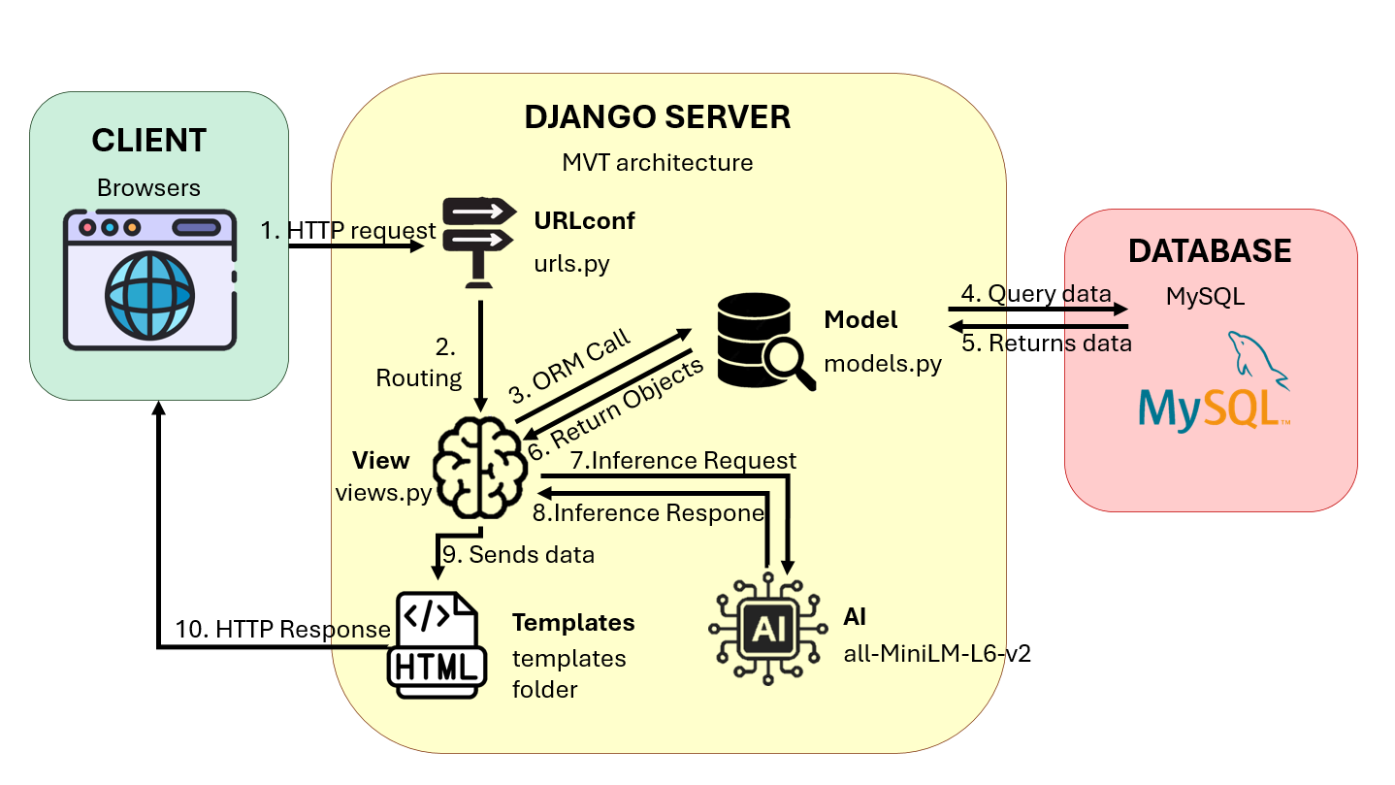

3.2 Sitemap: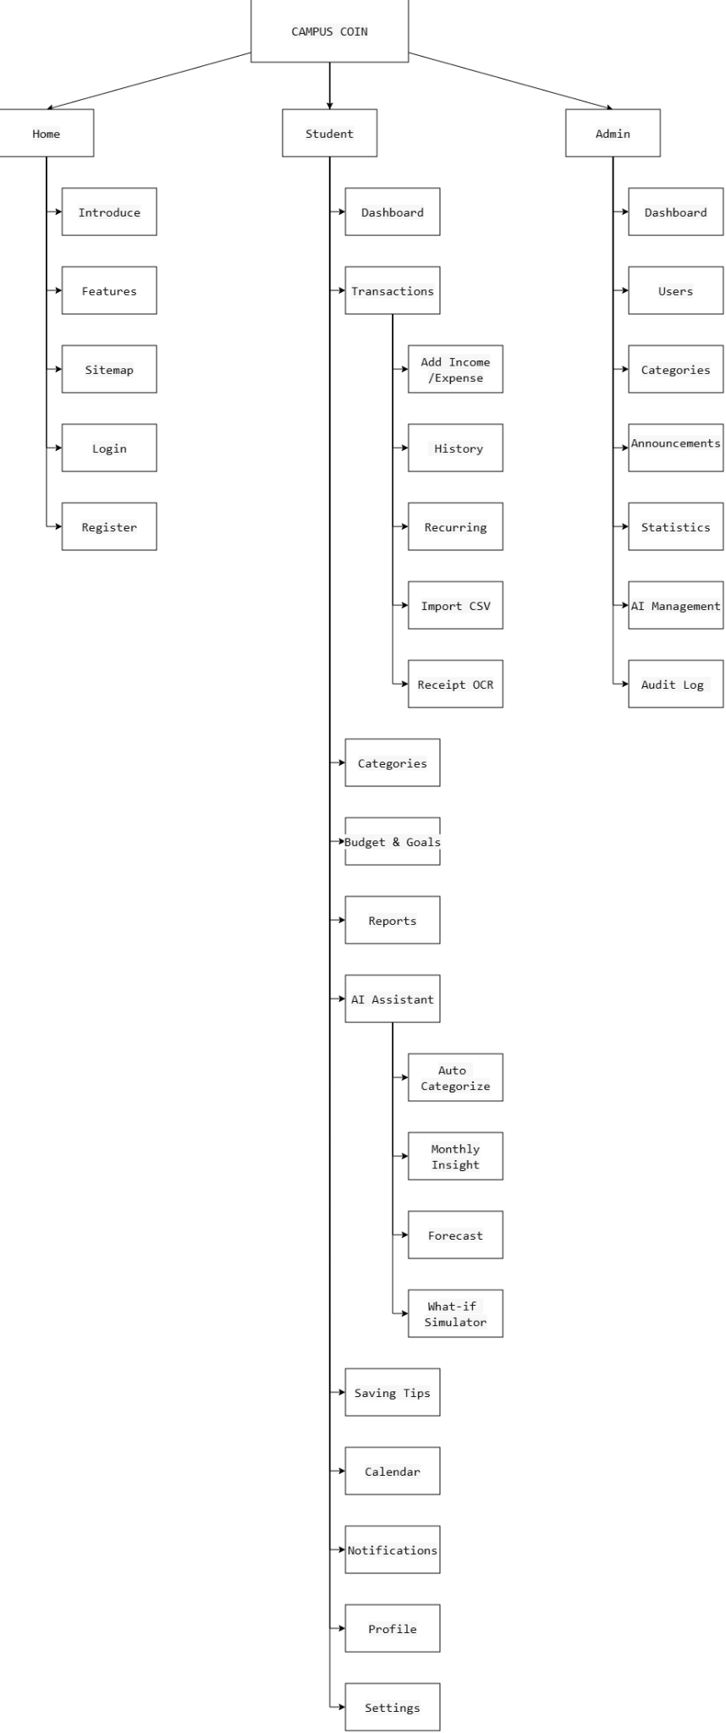

3.3. Account Module

- roles stores system permissions, including STUDENT and ADMIN.
- users stores login information.
- user_profiles stores detailed information for each user.
- The main relationships are roles (1) - (N) users and users (1) - (1) user_profiles.
3.4. Finance Module
- categories is the table for income and expense categories. Categories can be system defaults or user-created.
- transactions is the central table of the entire system because almost all dashboards, budgets, reports, and AI data are pulled from here.
- transaction_history stores the history of creating, editing, and deleting transactions.
- receipts stores invoice images and OCR data if the user inputs from an invoice.
- recurring_transactions is used for periodic transactions like allowances or subscriptions.
- csv_imports stores the history of importing transactions from CSV files.
3.5. Budget and Goals Module
- budgets stores spending limits by month and by category.
- savings_goals stores savings goals like buying a laptop or traveling.
- goal_contributions stores each contribution made to a savings goal.
- The main relationships are users (1) - (N) budgets, users (1) - (N) savings_goals, and savings_goals (1) - (N) goal_contributions.
3.6. AI Module
- ai_category_feedback stores AI category suggestions for transactions and user feedback.
- ai_insights stores monthly spending analysis.
- ai_chat_history stores the Q&A history with the AI assistant.
- financial_scenarios stores What-if Simulator data, such as the impact of reducing spending from current to suggested levels.
- ai_request_logs is used to track AI requests for administration and statistical purposes.
3.7. System and Admin Module
- saving_tips stores money-saving tips.
- user_tip_actions stores user actions regarding saving tips, such as pin, dismiss, or bookmark.
- notifications stores alerts such as nearing budget limits or having new insights.
- announcements stores system announcements created by admins.
- bookmarks stores content saved by users.
- audit_logs stores operation logs for control and auditing purposes.
- system_settings stores general dynamic system configurations.
RELATIONSHIPS AND SYSTEM FLOW OF CAMPUS COIN
Supporting document for presenting the database and website workflow
1. Purpose of the document
- This document helps briefly explain the business flow and relationships between tables in Campus Coin.
- The goal is to make it easy to understand when defending the web project, especially regarding the database, functions, and processing flow.

2. General system flow
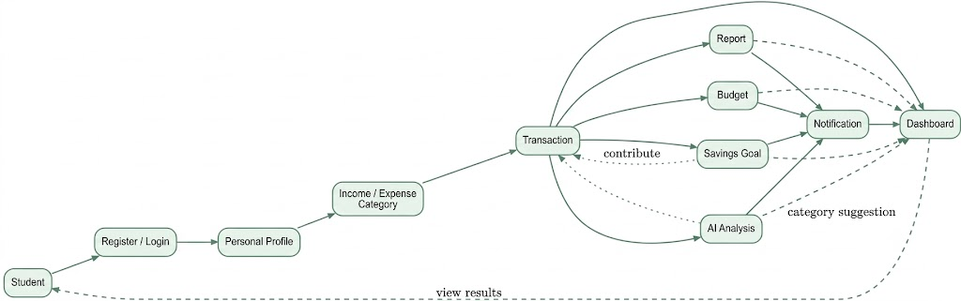
Figure 1. Main business flow of Campus Coin

- Students register or log in to use the system.
- After logging in, users set up their personal profiles, including full name, academic year, monthly allowance, and savings goals.
- Users create or use income/expense categories, then enter transactions.
- From the transaction data, the system generates a dashboard, budget, reports, AI insights, and savings goals.
- These results continue to generate notifications and loop back to display on the dashboard.

4. Summary table of important relationships
Relationship | Type | Meaning
roles → users | 1 - N | One role has many accounts
users → user_profiles | 1 - 1 | One account has one personal profile
users → transactions | 1 - N | One student has many transactions
categories → transactions | 1 - N | One category has many transactions
transactions → transaction_history | 1 - N | One transaction has many edit histories
transactions → receipts | 1 - 0..1 | One transaction may or may not have a receipt
users → budgets | 1 - N | One user has many monthly budgets
categories → budgets | 1 - N | Each budget is linked to a category
users → savings_goals | 1 - N | One user has many savings goals
savings_goals → goal_contributions | 1 - N | One goal has many contribution records
transactions → ai_category_feedback | 1 - N | One transaction can generate AI feedback
users → ai_insights | 1 - N | One user has many insights over time
users → notifications | 1 - N | One user receives many notifications
5. Brief presentation method for defense
6. First, I divide the system into 5 main modules: Account, Finance, Budget & Goals, AI, and System & Administration.
7. Among them, transactions is the central table because all subsequent analyses such as the dashboard, reports, budget, and AI insights pull data from transactions.
8. The most important relationships are users (1) - (N) transactions and categories (1) - (N) transactions.
9. To make the system more complete, I added transaction_history to save change history, receipts to support invoice OCR, and financial_scenarios to build a What-if Simulator.
10. Thanks to this structure, the database not only meets the functional requirements of the sitemap but is also scalable enough to develop further advanced features.
6. Conclusion
- If you need a very short presentation, just remember one main point: transactions are the center, users are the data owners, and categories are the basis for classifying spending.
- From these 3 components, the system expands to budgets, reports, AI insights, notifications, and savings goals.
MYSQL DATABASE DESIGN
CAMPUS COIN - COMPETITION EDITION
ERD and data structure supporting a fully functional Sitemap
Design scope: 26 tables, covering accounts, transactions, budgets, savings goals, reports, AI, OCR, saving tips, notifications, and system administration.
1. General ERD
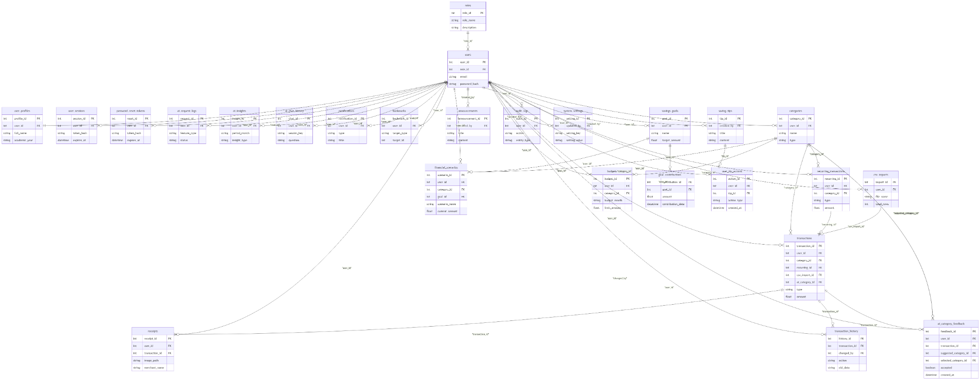
Figure 1. General ERD for Campus Coin. The accompanying Draw.io file contains a detailed editable version.
2. Structure by module
- Account & Security: roles, users, user_profiles, user_sessions, password_reset_tokens.
- Transactions: categories, transactions, transaction_history, recurring_transactions, csv_imports, receipts.
- Budget & Goals: budgets, savings_goals, goal_contributions.
- AI & Intelligence: ai_category_feedback, ai_insights, ai_chat_history, financial_scenarios, ai_request_logs.
- Saving & Engagement: saving_tips, user_tip_actions, notifications, bookmarks.
- Admin & System: announcements, audit_logs, system_settings.
3. List of 26 tables
No. | Table | Module | Main Purpose
1 | roles | Account & Security | Student/Admin roles
2 | users | Account & Security | Login accounts
3 | user_profiles | Account & Security | Student profiles
4 | user_sessions | Account & Security | Login session management
5 | password_reset_tokens | Account & Security | Password recovery
6 | categories | Transactions | System and personal income/expense categories
7 | transactions | Transactions | Central table storing income and expenses
8 | transaction_history | Transactions | Stores all change/delete history
9 | recurring_transactions | Transactions | Recurring transactions
10 | csv_imports | Transactions | Tracks CSV imports
11 | receipts | Transactions | Invoice images and OCR results
12 | budgets | Budget & Goals | Budgets by category/month
13 | savings_goals | Budget & Goals | Savings goals
14 | goal_contributions | Budget & Goals | Contributions to goals
15 | ai_category_feedback | AI & Intelligence | Feedback to improve category suggestions
16 | ai_insights | AI & Intelligence | Monthly insights and forecasts
17 | ai_chat_history | AI & Intelligence | Ask Campus Coin history
18 | financial_scenarios | AI & Intelligence | What-if Simulator
19 | ai_request_logs | AI & Intelligence | Tracks AI requests and errors
20 | saving_tips | Saving & Engagement | Repository of saving tips
21 | user_tip_actions | Saving & Engagement | Pin/Dismiss/Bookmark tips
22 | notifications | Saving & Engagement | Notifications and alerts
23 | announcements | Admin & System | Announcements published by Admin
24 | bookmarks | Saving & Engagement | Bookmarked tips/insights/reports
25 | audit_logs | Admin & System | Admin/system operation logs
26 | system_settings | Admin & System | Dynamic system configurations
4. Main relationships
- roles 1 - N users: one role has many accounts.
- users 1 - 1 user_profiles: each user has one profile.
- users 1 - N transactions: each user has many transactions.
- categories 1 - N transactions: each transaction belongs to one category.
- transactions 1 - N transaction_history: all changes are logged in history.
- transactions 1 - 0..1 receipts: a transaction can be created from an OCR invoice.
- users/categories 1 - N budgets: budgets are set by user and category.
- users 1 - N savings_goals and savings_goals 1 - N goal_contributions.
- users 1 - N ai_insights, ai_chat_history, financial_scenarios, and ai_request_logs.
- saving_tips 1 - N user_tip_actions: stores Pin, Dismiss, and Bookmark actions.
- users 1 - N notifications, announcements, audit_logs, and related admin data.
5. Mapping Sitemap to Database
Sitemap Function | Supporting Tables
Login, Register, Profile | users, roles, user_profiles, user_sessions, password_reset_tokens
Transactions, History, Recurring | transactions, transaction_history, recurring_transactions
CSV Import, Receipt OCR | csv_imports, receipts, transactions
Categories | categories
Budget & Goals | budgets, savings_goals, goal_contributions
Reports & Dashboard | queried from transactions, categories, budgets, savings_goals
AI Categorization | ai_category_feedback + transactions.ai_category_id
AI Insight, Forecast, AI Chat | ai_insights, ai_chat_history, ai_request_logs
What-if Simulator | financial_scenarios
Saving Tips, Bookmark | saving_tips, user_tip_actions, bookmarks
Notifications & Announcement | notifications, announcements
Admin & Audit | users, categories, announcements, audit_logs, system_settings
6. Design notes
- No separate Dashboard or Reports tables are created. These two functions are aggregated by querying data from transactions, budgets, and goals.
- Transactions use soft delete (deleted_at) to avoid losing history when users delete a transaction.
- categories.user_id is allowed to be NULL to represent system-wide default categories. Personal categories will have a user_id.
- AI only stores suggestions, feedback, insights, and logs. Users still have the right to edit or overwrite suggestions.
- For real SQL deployment, UNIQUE and INDEX constraints should be added for email, role_name, setting_key, foreign keys, and commonly used columns for daily/monthly filtering.
Diagram edit file: https://drive.google.com/file/d/1OD4cYbOQmVQAns2Ncbu1pWcHC1ZhL3Sr/view?usp=sharingCampusCoin_ERD_Competition.drawio

4 Use Case Diagram:

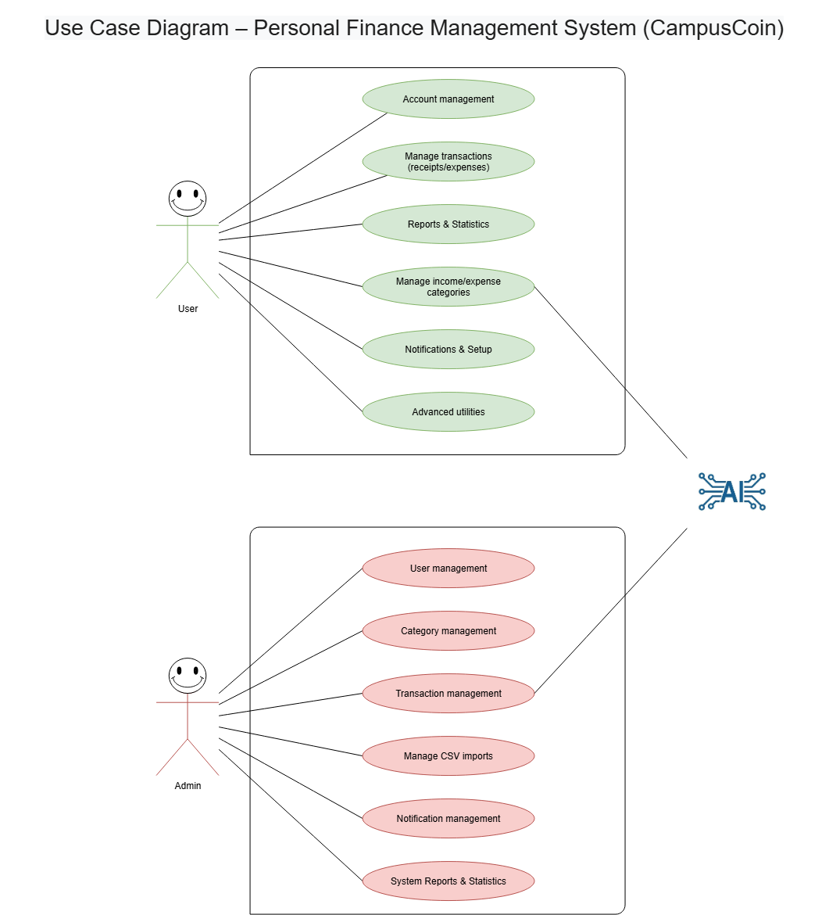

Link github: https://github.com/ntvana25033-create/TECHWIZ-7-Flying-Pig-Wizard---End-to-End-Web

QR github

